How to deploy Nodejs project with DevOps

1. Create an nodejs application with IBM Bluemix
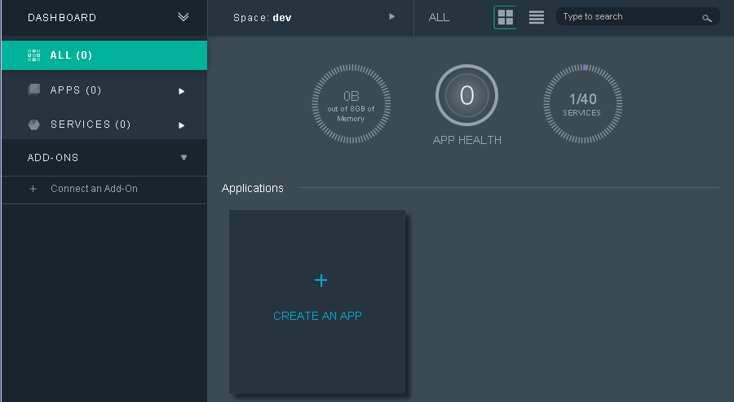
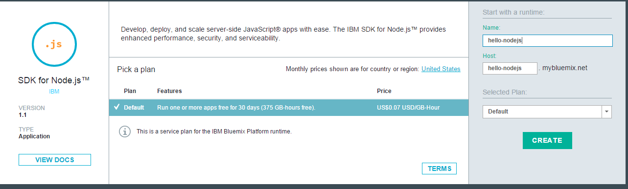

2. Enable Git integration and auto-deployment with DevOps Services
Click ADD GIT to give you a Git repository that's loaded with example code and a deployed application.
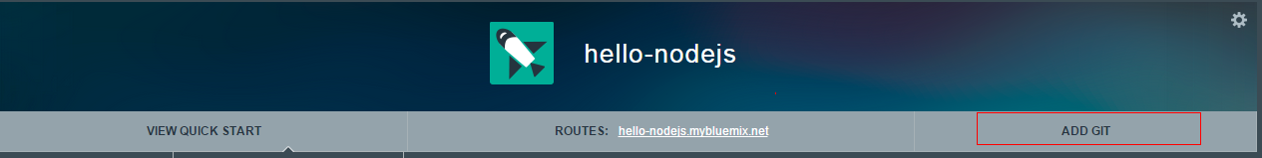
Login with your devops id to create git repository
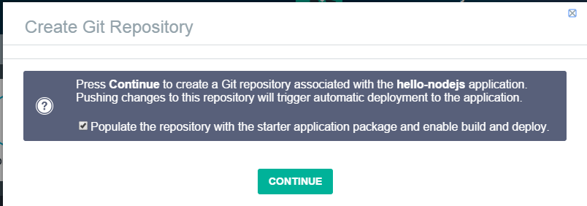
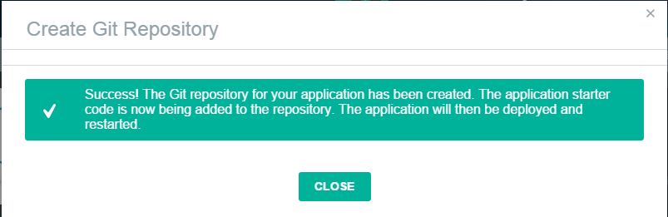
Now the nodejs project has connected to Jazz
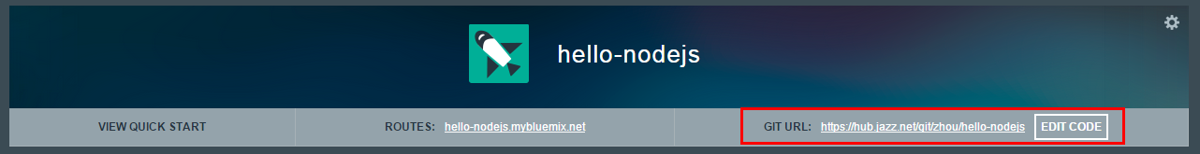

3.Push changes to the Git repository
To change source code, you can use git command (see http://git-scm.com/doc to learn working with git)
Or you can use Web IDE provided by Jazz
Click EDIT CODE to open project in WEB IDE
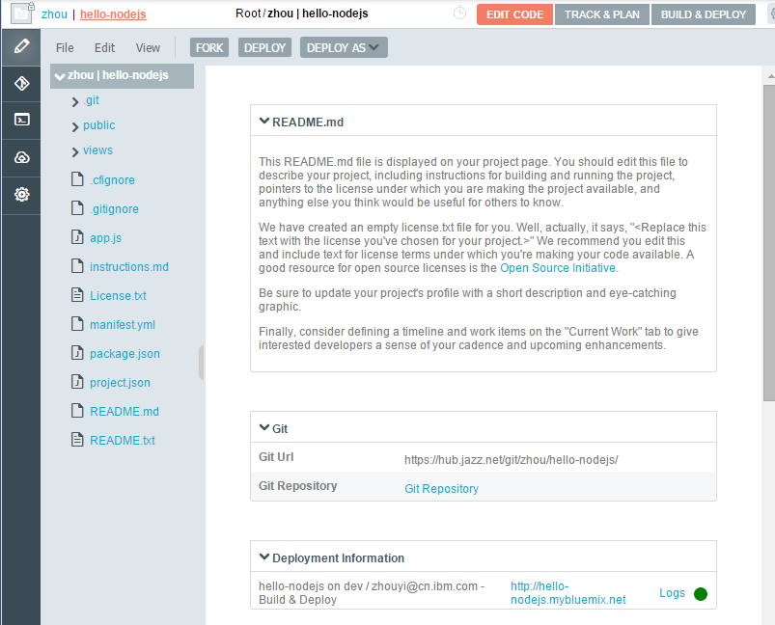
From this environment, you can edit the files
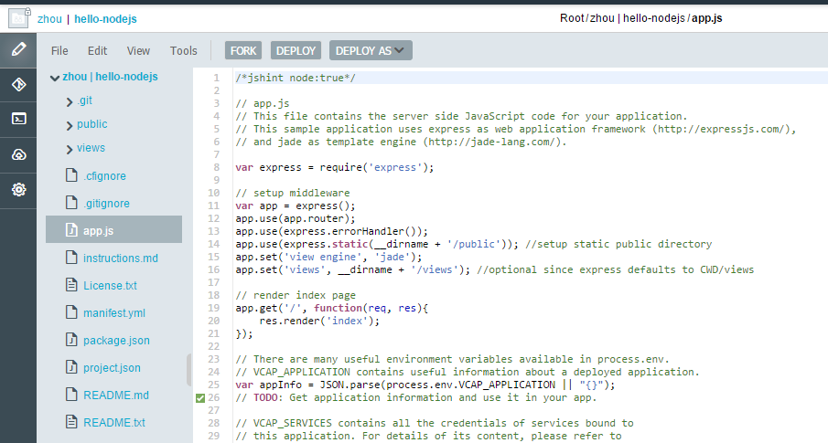
Once you finished changing, you can then use the integrated Git support to push the change. Switch to the Git Repository page and follow these steps:
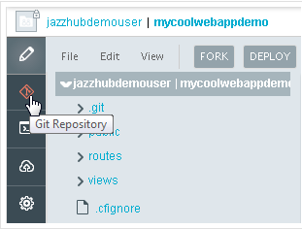
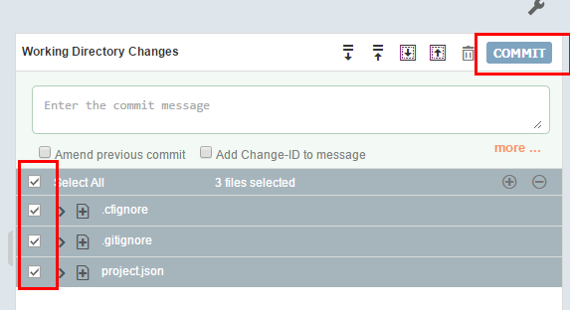
Then push your changes to repository
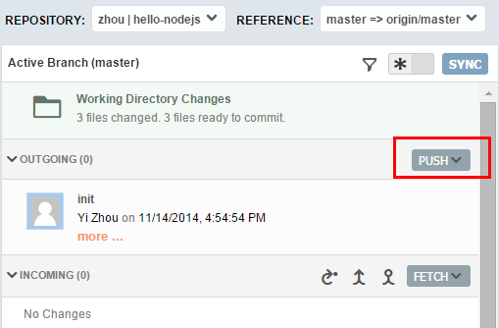
Go to the BUILD & DEPLOY page, wait until it shows that the application was deployed again
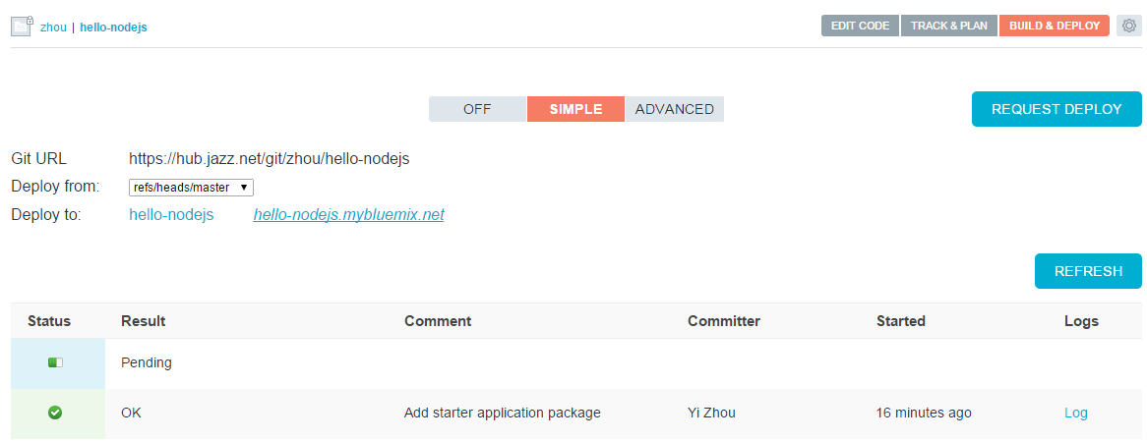
When pending status is changed to OK. It means the code has deployed to the specific bluemix.

